**het mummificatieproces**

[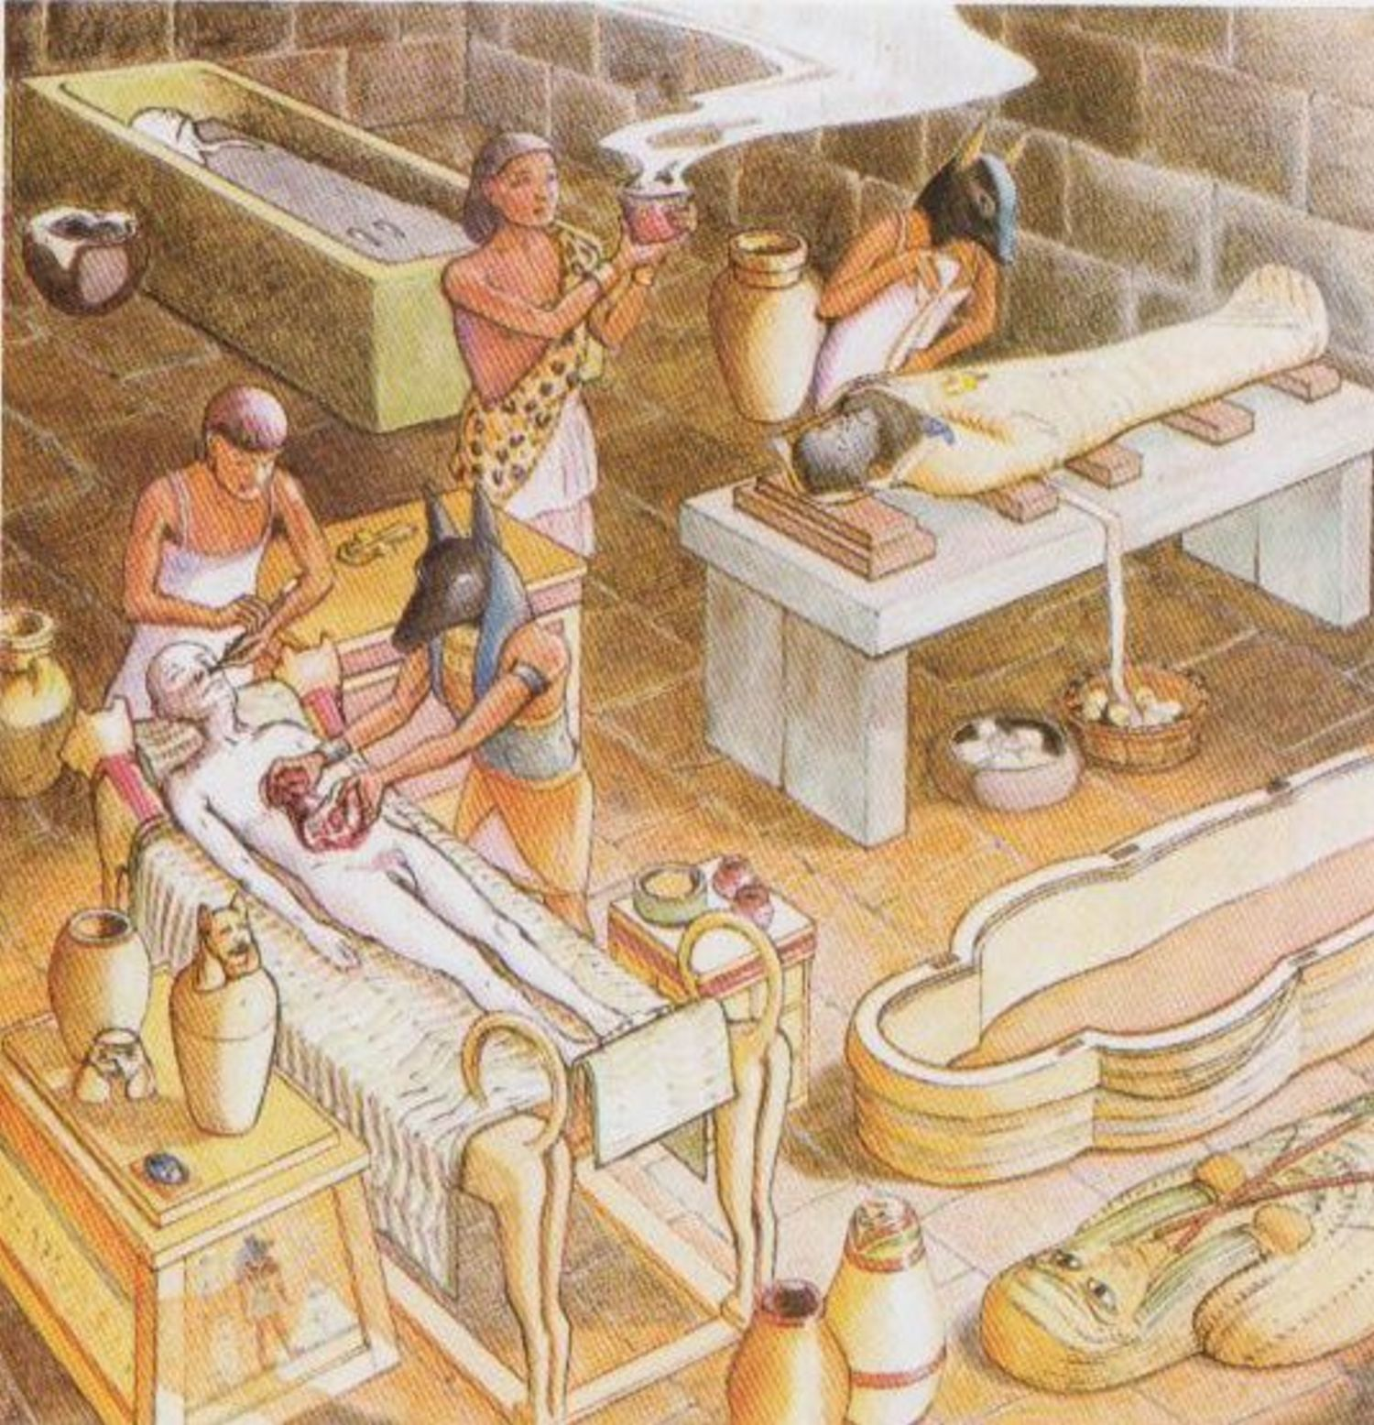](https://www.google.be/url?sa=i&rct=j&q=&esrc=s&source=images&cd=&cad=rja&uact=8&ved=2ahUKEwiQ6tPf9vTgAhUGPFAKHZrQDkUQjRx6BAgBEAU&url=https%3A%2F%2Foudeegypte.wordpress.com%2Fmummificeren%2F&psig=AOvVaw1T_xmirzgZbDXDyLFEBllV&ust=1552209839349363)